MAINE MOTOR VEHICLE FRANCHISE BOARD

M.M.V.Bd. No. 17-01, COUNT VII
Darling's, )
Petitioner, ) ORDER ON RECONSIDERATION of MOTIONS
) FOR SUMMARY JUDGMENT
)
)
v. ) )
)
Ford Motor Company, )
Respondent. )

The Maine Motor Vehicle Franchise Board issued an ORDER on December 19, 1919, which partially GRANTED Darling’s motion for summary judgment, and DENIED Ford’s motion for summary judgment and Darling’s motion in limine. That ORDER sets out the procedural history which led to it.
Pending before the Board is DARLING’S January 14, 2020 MOTION FOR RECONSIDERATION. On February 5, FORD filed its RESPONSE to DARLING’S MOTION FOR RECONSIDERATION, and its RESPONSE to DARLING’S MOTION TO AMEND BOARD’S MAY 16, 2017, ORDER SEALING COUNT VII OF COMPLAINT; On February 18, DARLING’S REPLIED to FORD’S RESPONSE to DARLING’S MOTION FOR RECONSIDERATION, and to FORD’S RESPONSE to DARLING’S MOTION TO AMEND BOARD’S MAY 16, 2017, ORDER SEALING COUNT VII OF COMPLAINT.
Having considered all the above filings, DARLING’S MOTION FOR SUMMARY JUDGMENT is GRANTED as set forth below; Ford’s MOTION FOR SUMMARY JUDGMENT is DENIED.

- Darling’s became a Ford franchisee in September, 1989, and has remained a Ford franchisee since that time. (DMSJ, J. Darling Affidavit ¶¶ 3-4, Ex. A)
- That relationship is based upon Ford’s Sales and Service Agreement (SSA) which dealers must sign in order to become Ford dealerships. Ford Motor Company v. Darlings et al. 2014 ME 7, ¶ 4
- Title 10 M.R.S.A., the Dealers Law Title 5 § 1176 provides as follows:
If a motor vehicle franchisor requires or permits a motor vehicle franchisee to perform labor or provide parts in satisfaction of a warranty created by the franchisor, the franchisor shall properly and promptly fulfill its warranty obligations, in the case of motor vehicles over 10,000 pounds gross vehicle weight rating, shall adequately and fairly compensate the franchisee for any parts so provided and, in the case of all other motor vehicles shall reimburse the franchisee for any parts so provided at the retail rate customarily charged by that franchisee for the same parts when not provided in satisfaction of a warranty.

- Section 1176 also describes a process by which a motor vehicle dealer’s “retail rate customarily charged” is determined – by declaring an average percentage markup. As a franchisee of Ford, Darling’s is required to perform warranty repairs on any and all Ford vehicles presented to it for repair. When performing those warranty repairs, Darling’s is required to purchase the parts used in those repairs from Ford or as directed by Ford. (DMSJ, Darling Affidavit ¶ ¶ 6, 7)
- Ford classifies various replacement parts as “core parts.” Ford ascribes a value or “core charge” to such parts. (DMSJ, J. Darling Affidavit, ¶8) These are broken or worn out parts which retain value because they can be re-worked and re-used. (DSOMF Ex. C at 57:16-25).
- Before September of 2013, Ford refused to pay Darling’s its statutory “markup” payments on the core charge associated with these parts. (Darling Affidavit, supra, ¶9)
- The statute does not address this issue, and Darling’s had long sought “markup” payments for core parts in the District Court. (SOMF Ex. O) Darling’s Auto Mall v. General Motors LLC, 2016 ME 48, 12 and passim.
- In November of 2012, John Darling of Darling's emailed Wayne Potter of Ford and asked if Ford would voluntarily agree to pay Darling's statutory markup on core charges in future warranty claims. (DSOMF, Ex C at 103:19-1 04:8; and Ex. D)
- The parties negotiated Darlings’ demand for core markups during much of 2013. John Darling stated several times during the negotiation, first to Wayne Potter and then to Pat Curtin, Wayne Potter's replacement, that he was seeking not only payment of core markups for the warranty claims submitted by Darling's in the four years preceding the start commencement of settlement negotiations, but also on all future warranty claims on core parts. (Darling’s SOMF, Ex.C at 92:12-22, 95:15-24, 100:24-101:9, 112:10-22, 133:9-18, 137:1-2, 143:18-144:4, 145:7-12; 180:1-12, 183:2-6, 23, 191:9-18, 193:1-3, and 194:10-14, Ex. D, Ex. E at 50:2-11)
- On September 17, 2013, Ford Warranty Analysis & Policy Manager, Pat Curtin, emailed John Darling that he believed “…we can reach agreement that” Ford would pay eligible past core claims at a rate of an 80% markup of the underlying core charge amount; that going forward, Ford would pay a markup of 96.3% on core charges, on vehicles under 10,000 GVWR, and a markup of 75% on vehicles over 10,000 GVWR; Darling's would submit separate claims to Ford for these core charges; Darling's would execute a full release including a waiver of claims to civil penalties on core charges and a confidentiality agreement; Ford would agree not to pursue what it believes to be past overpayments on non-core parts; and Ford would pay reasonable attorneys' fees and costs relating to the existing filed small claims actions. He added that “[t]he key area still to work out is what past core charges are to be paid.” (DSOMF, Ex. M to SOMF, Ex. C 227:20-228:5, and Ex. M.).
- On September 18, 2013, John Darling acknowledged Darling's agreement to Ford's proposal with minor tweaks to a few points. (DSOMF, Ex. C 231:I 4-232:9, and Ex. N)
- On September 19, 2013, Pat Curtin called John Darling and confirmed Ford's acceptance of the minor changes contained in John Darling's September 18, 2013 email. (DSOMF, Ex C, 254:1-10, 266:12-20, Ex. O; F Opp. SOMF, Ex. W)
- “[A]fter September 19, the back and forth focused on the dollar amount to be paid in past claims and finalizing the terms of a release on those claims.” (DSOMF Ex. O, November 26, 2013 Rosenthal to Metcalf)
- On October 28, John Darling signed the Release which settled the “key area” of past core charges, “between January 1, 2009 and August 31, 2013.” Ford agreed to pay Darling’s an 80% markup on core parts used by Darling’s during that period, but the Release did not contain that term. (Ex. M and O to DSOMF)
- In his November 26, 2013 communication to Darling's counsel, attorney Rosenthal, on behalf of Ford, stated that Darling's and Ford had an enforceable and confidential settlement agreement; expressed in the emails between Pat Curtin of Ford and John Darling of Darling's on September 17, and 18, 2013; that Pat Curtin confirmed the settlement on September 19, 2013 during a telephone conversation with John Darling; and said that Darling's breached the confidential settlement agreement when it allowed its employee to testify on November 1 , 2013, in an unrelated proceeding, that Ford currently pays a core markup. (DSOMF, Ex. O)
- Pat Curtin agreed that Attorney Rosenthal was an external attorney for Ford, and that Attorney Rosenthal's statement that the parties had a deal on the terms reflected in the September 18, 2013, email from John to Pat was true. (DSOMF Ex. C at 255:14-17; 260:20-25; 263:1-8; 268:24-269:1)
- From September 19, 2013 until August 29, 2016, Darling's submitted its core markup-claims to Ford, and Ford paid them as the parties had agreed. (id.at 202:15-22; Exhibit E 170:12-I 8)
- The agreement that Ford would reimburse Darling’s for future core parts was “…sufficiently definite….” for Ford and Darling’s to refer to it as the “agreement,” and both parties abided by its terms for almost three years. White v. Fleet Bank of Maine et al., 2005 ME 72, ¶ 12.
- Both Ford and Darling’s followed the terms of their agreement on core parts for three years. (DSOMF Ex. M)
- On March 21, 2016, the Law Court ruled that the Dealers Act did not require manufacturers to reimburse dealers for core parts. Darling’s Auto Mall v. General Motors LLC, 2016 ME 48, ¶¶ 7, 12.
- Five months later, apparently by regular mail letter of August 29, 2016, Ford, mistakenly attributing the Law Court’s decision to the Superior Court, informed Darling’s that it would no longer reimburse it for core parts. (DSOMF, Ex. P) The letter Ford’s letter did not refer to the parties' almost three-year old agreement, nor how the legal decision it mentioned could control that agreement. (id., Ex. N)
- Ford admitted that it was not communicating with anyone at General Motors (GM) regarding its litigation with Darling’s, and that it was always possible that GM might settle or otherwise not pursue the appeal of the core charges. (DRSOMF ¶ 16)
- “The disparity in bargaining power between automobile manufacturers and their dealers prompted the Maine Legislature to enact legislation to protect dealers from actions by manufacturers that were perceived as abusive and oppressive.” Arcadia Motors Inc., v. Ford Motor Company, 844 F. Supp. 819, 827-28, (US District Court, D. Me, 1994) The Maine “Dealers Act “was the result. 10 MRSA Ch. 204, §§ 1174 et seq.
- The Act protects the parties from actions which are taken in bad faith. §1174 (1), and see Darling’s d/b/a/ Darling’s Bangor Ford v. Ford Motor Company, 1998 ME 232, ¶ 14, contrasting bad faith under the statute with good faith: “honesty in fact and the observation of reasonable commercial standards of fair dealing in the trade.”
- The Dealers Act contains some three dozen prohibitions and limitations which the Legislature imposed on manufacturers in order to protect Maine dealers. See, for instance, §§ 1171 (3) and 1174 (2), (3)(A).
- Agreements subject to this chapter. Written or oral agreements between a manufacturer, wholesaler or distributor with a motor vehicle dealer including, but not limited to, the franchise offering, the franchise agreement, sales agreements, policies and procedures agreements, bulletins or manuals, sales of goods, services or advertising, leases or mortgages of real or personal property, promises to pay, security interests, pledges, insurance contracts, advertising contracts, construction or installation contracts, servicing contracts, and all other such agreements in which the manufacturer, wholesaler or distributor has any direct or indirect interest, are subject to this chapter.
Tit. 10 § 1178 and see Darling’s Auto Mall v. General Motors LLC, 2016 ME 48, 3. This expansive language applies to the parties’ agreement now at issue.

- In plain language, section 1174(3) of the Dealers Act was intended to afford a dealer notice and a process required when a manufacturer seeks to change a program under the SSA which it had imposed to begin with. In contrast, the parties here negotiated to compromise a longstanding legal issue between them, settling both the past and future occurrences. It was a separate contract between them, not subject to §1174(3).
- Applying §1174(3) to this matter would lead to an “illogical or absurd result,” enabling Ford to abrogate an agreement which it had negotiated to settle a longstanding disputed legal issue between Ford and Darling’s. Estate of Zoa J. Spear, 1997 ME 15, ¶ 17.
- “Summary judgment is … a procedural device…appropriate if the pleadings, depositions, answers to interrogatories and admissions on file, together with affidavits, if any, show there is no genuine issue of material fact, and any party is entitled to judgment as a matter of law.” Darling’s v. Ford Motor Company, 2003 ME 21, ¶ 4, citing Civ. R 56 (c).
- Darling’s Motion for Summary Judgment establishes that Ford and Darling’s agreed on a procedure for Darling’s to seek reimbursement for core parts from Ford, and the rates at which Ford would reimburse Darling’s. They then reached a separate agreement and executed a release to settle Darling’s claims for reimbursement of core parts. Their agreement “was both expressly [and] impliedly manifested in the contract.” Sullivan v. Porter, 2004 ME 134, ¶ 12, and see McClare v. Rocha, et al. 2014 ME 4, ¶¶ 20, 21, and Muther v. Broad Cove, 2009 ME 27, ¶ 6.
- Ford violated § 1174(1) when it stopped paying Darling’s for core parts under their agreement on or about September 1, 2016. (DOSOMF, Ex. L)
WHEREFORE:
Darling’s motion for summary judgment is GRANTED; Ford’s motion for summary judgment is DENIED. This matter shall be set for ARGUMENTS addressing civil penalties.
SO ORDERED
June 4, 2020 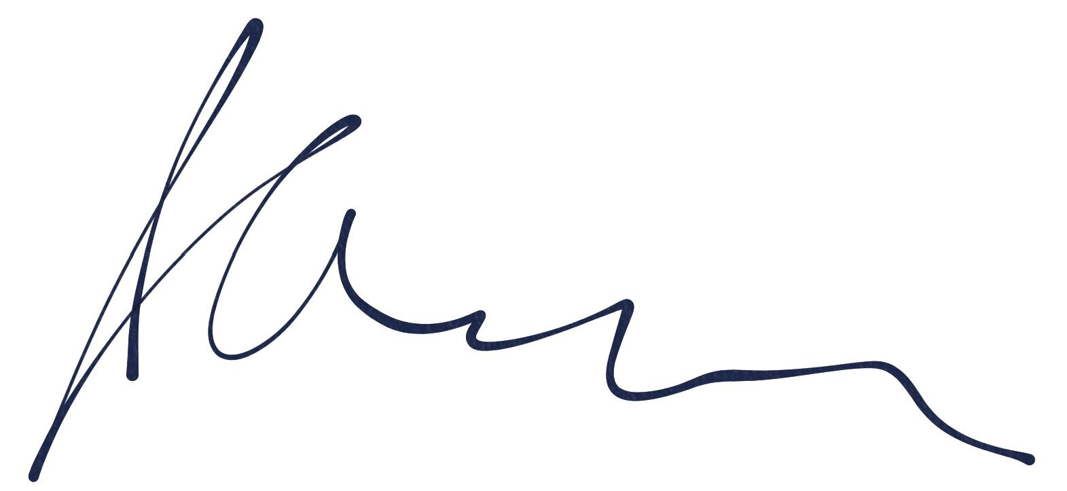
______________________________
John McCurry, Chairman
Maine Motor Vehicle Franchise Board

